**DA - ECHARGING OPERATORS**

**PROBLEM STATEMENT:**

* The E-Charging Operators (equivalent of today's petrol pump operators) need a prediction to ensure their customers (end-users) satisfaction and optimum utilization of the e-Charging stations.
* The operator may have fast or slow charging infrastructure with their own payment terms and timings.
* With the help of machine learning algorithms the operator can **offer dynamic pricing at stipulated times** and manage the peak demand accordingly.
  + The pricing structure can also be based on the more or less charging time taken.

**REQUIREMENTS:**

* Jupyter Note Book
* Data set

**MACHINE LEARNING:**

* Machine learning (ML) is the [scientific study](https://en.wikipedia.org/wiki/Branches_of_science" \o "Branches of science) of [algorithms](https://en.wikipedia.org/wiki/Algorithm" \o "Algorithm) and [statistical models](https://en.wikipedia.org/wiki/Statistical_model" \o "Statistical model) that [computer systems](https://en.wikipedia.org/wiki/Computer_systems" \o "Computer systems) use to effectively perform a specific task without using explicit instructions, relying on patterns and inference instead.
* It is seen as a subset of [artificial intelligence](https://en.wikipedia.org/wiki/Artificial_intelligence" \o "Artificial intelligence).
* Machine learning algorithms build a mathematical model of sample data, known as "[training data](https://en.wikipedia.org/wiki/Training_data" \o "Training data)", in order to make predictions or decisions without being explicitly programmed to perform the task.

**Project Description**

* In this project three types of machine learning algorithms are used for prediction.
* They are

1. Kmeans
2. Linear regression
3. Decision Tree

* This project helps the E charging operators to find the proper pricing structure of their E charging stations according to the fast or slow charging infrastructure.

**INPUT**

* The input is given in the form of data set where the data set contains total details of an E charging station kept in account for a year.
* It provides the energy consumed, Charge time, price, unique customers,etc.
* That is considered to be the train data set which is used to train the algorithms.
* The inputs are gathered from the given data set and all the 3 algorithms are written on own to train the given data set and also for the prediction.
* The algorithms are written in **python** programming language.

The original data set used for predictions.

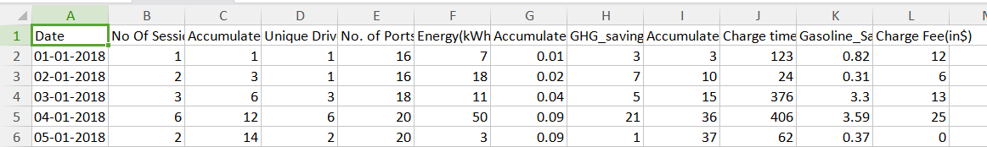

The same data set with some extra columns used for k means clustering.

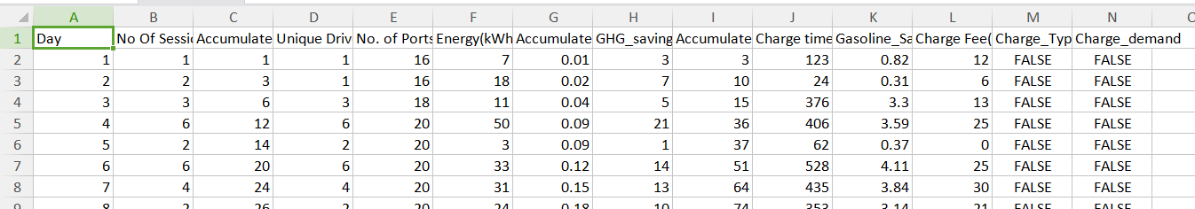

**EXSISTING SYSTEM**

* With the rapid increase in the penetration level of electric vehicles (EVs), accurate modelling of the impacts of EVs on the electricity grid in cities is of important value to grid operators.
* Then a spatial model is developed and validated using the previously analysed data. The results show that there is a big difference in the occupancy rate of stations. Some stations are more frequently used than others.
* The price prediction was done only based on a survey with the society and not with any predictions.

**PROPOSED SYSTEM**

* A battery swapping (or switching) station is a place at which a vehicle's discharged battery or battery pack can be immediately swapped for a fully charged one, eliminating the delay involved in waiting for the vehicle's battery to charge.
* In this system, Using the Machine learning algorithms like K-means, Linear Regression and decision tree algorithms the pricing structure according to the demand and the infrastructure is predicted.
* It was done by finding the prediction score and accuracy for each algorithms and selecting an algorithm which has the high accuracy rate compared to the other two.

**ADVANTAGES OVER EXISTING SYSTEM**

* Easy to predict.
* Accuracy is obtained
* easy to fulfill a demand.

**DRAWBACKS OF EXISTING SYSTEM**

* The number of electrical vehicles continues to increase but EV charging infrastructure remains underdeveloped and insufficient.
* This is because of the some people who are afraid to build an E charging station as they think they may suffer loss due to improper pricing structure.
* Most of the operators does not have an idea how to place an pricing structure for fast and slow charging infrastructure.

**OUTPUT**

* The first output will be prediction of all the algorithms and the visualization of K means clustering.
* After the prediction all the algorithm’s prediction score is considered and the accuracy value of each algorithm is found out.
* By comparing all the accuracy value, the algorithm which has the highest accuracy rate is considered as the best and suitable algorithm for the given problem statement and data set.

**SCREENSHOTS**

1. **The output of the data cleaning.**

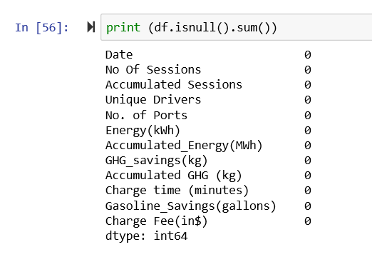

1. **The output of the k means clustering with 3 clusters.**

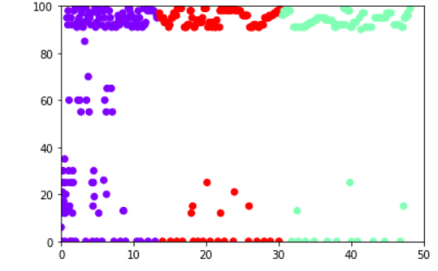

1. **The output of the linear regression where there is a pricing structure for the cooked up data provided.**



1. **The output of the decision tree where the pricing structure for the cooked up data is predicted.**

